**Custom Training – Day 06**

**September 05, 2023**

1. **Create Azure Storage Account with LRS:**

Locally Redundant Storage (LRS) Locally Redundant Storage (LRS) is a cost-effective data redundancy option within Azure Storage. It replicates your data three times within a single datacenter in a selected region, ensuring high availability and durability against hardware failures or issues specific to that datacenter.

LRS is suitable for scenarios where the primary concern is protecting data from localized outages, such as hardware failures or maintenance events, within a single datacenter. While it offers strong data resilience within the chosen region, it does not protect against broader disasters or regional outages, making it important to consider your speciϐic availability and disaster recovery requirements when selecting this option.

1. **Creating Storage Account with ZRS:**

Zone-redundant storage (ZRS) is a data replication strategy offered by Microsoft Azure to ensure high availability and data durability in cloud storage solutions. With ZRS, your data is redundantly stored across multiple availability zones within a region. Availability zones are physically separate data centers with independent power, networking, and cooling infrastructure.

This redundancy provides several advantages. First, it enhances data resilience by protecting against hardware failures, network outages, or other unforeseen issues within a single data center. If one availability zone experiences a problem, your data remains accessible from other zones without interruption. This ensures business continuity and minimizes downtime.

Additionally, ZRS ensures data durability by maintaining multiple copies of your data in different zones. This redundancy helps safeguard your data against data corruption, accidental deletions, or other data loss scenarios.

1. **Creating Storage Account with GRS:**

Geo-redundant storage (GRS) is a cloud storage concept offered by many cloud service providers, including Microsoft Azure and Amazon Web Services (AWS). GRS is designed to enhance data durability and availability by replicating data across multiple geographically dispersed data centers. In a GRS setup, when you store data in the cloud, it is automatically copied to a secondary data center located in a different geographic region from the primary one. This secondary data center serves as a backup in case of hardware failures, data corruption, or even regional disasters that might affect the primary data center. The replication process is typically synchronous, ensuring that data is mirrored in real-time or with minimal latency, thus reducing the risk of data loss. GRS provides a high level of data resilience and availability, making it a valuable option for organizations that require robust disaster recovery and business continuity solutions. While it may come at a slightly higher cost compared to other storage options due to the additional infrastructure required, the peace of mind and data integrity it offers are often worth the investment, especially for critical business data and applications.

1. **Creating a Storage Account with GZRS:**

Geo-Zone-Redundant Storage (GZRS) is a specialized data redundancy and availability feature offered within Microsoft Azure Storage. It is an extension of the Geo-Redundant Storage (GRS) concept but provides an even higher level of data resilience. In GZRS, data is replicated not only across multiple data centers within the same geographic region (like GRS) but also across different availability zones within that region. Azure availability zones are physically separate data centers with independent power, cooling, and networking. This means that GZRS offers protection against not only data center failures but also against failures at the availability zone level.

One of the key advantages of GZRS is its ability to provide a higher level of data durability and availability. In case of an outage in one availability zone or a regional disaster, data remains accessible from another availability zone within the same region, ensuring minimal downtime and data loss. This makes GZRS an ideal choice for mission-critical applications and workloads that require robust disaster recovery capabilities. However, it's important to note that GZRS may come at a higher cost compared to standard storage options due to the added redundancy and infrastructure required. Organizations should carefully assess their data resilience needs and budget constraints when considering GZRS for their Azure Storage deployments.

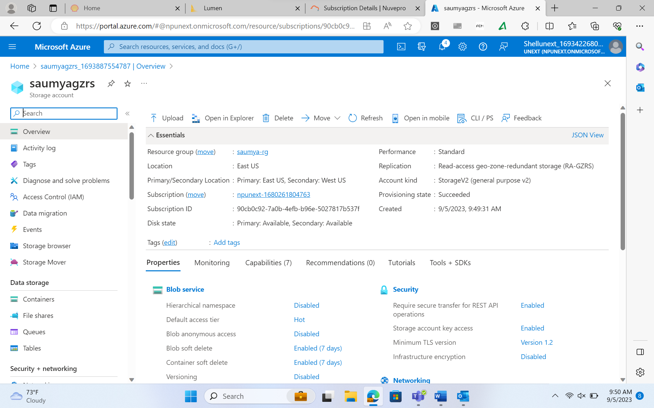

1. **Creating a container:**

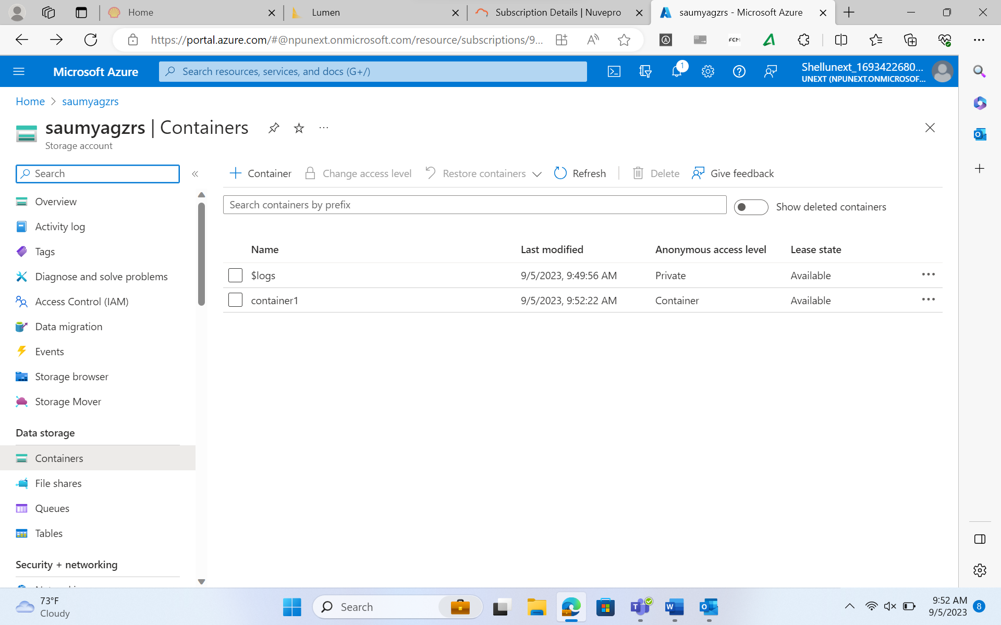

**Uploading a file in the container:**

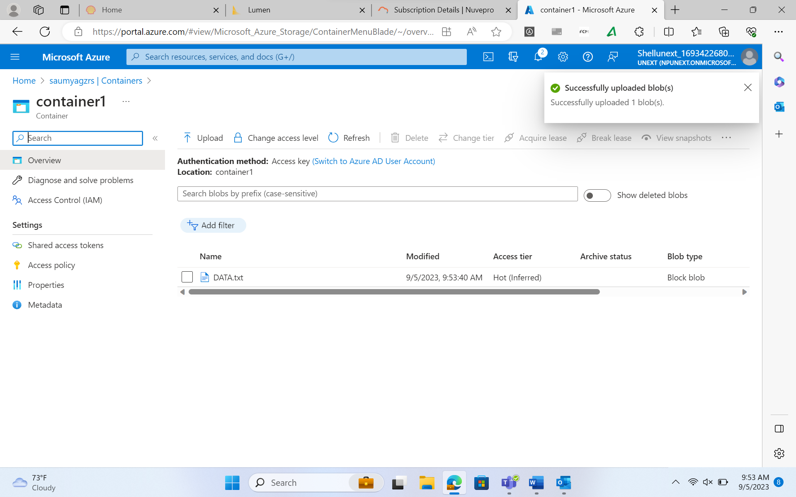

1. **SNAPSHOT:**

**Editing the data in the file:**

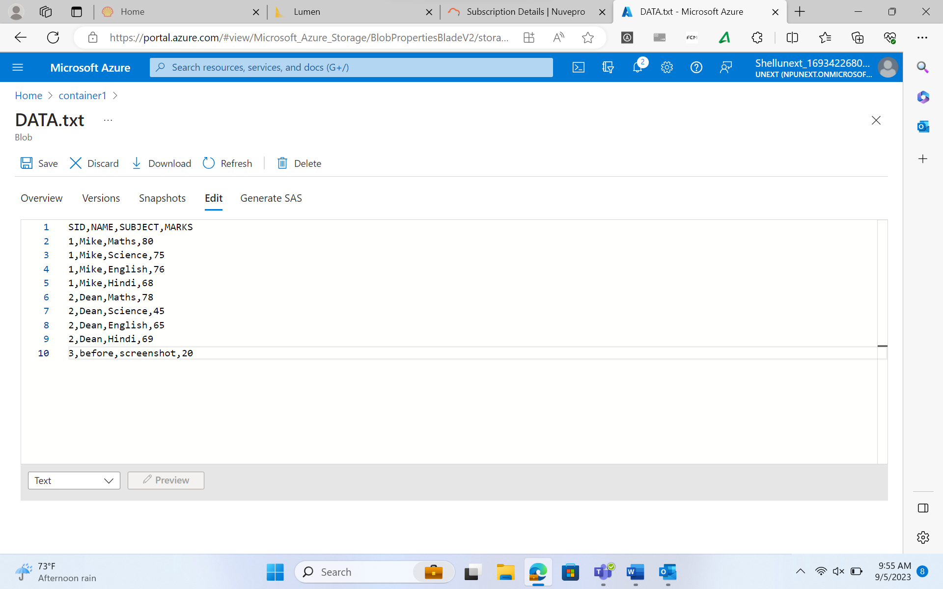

**Creating Snapshot of the data:**

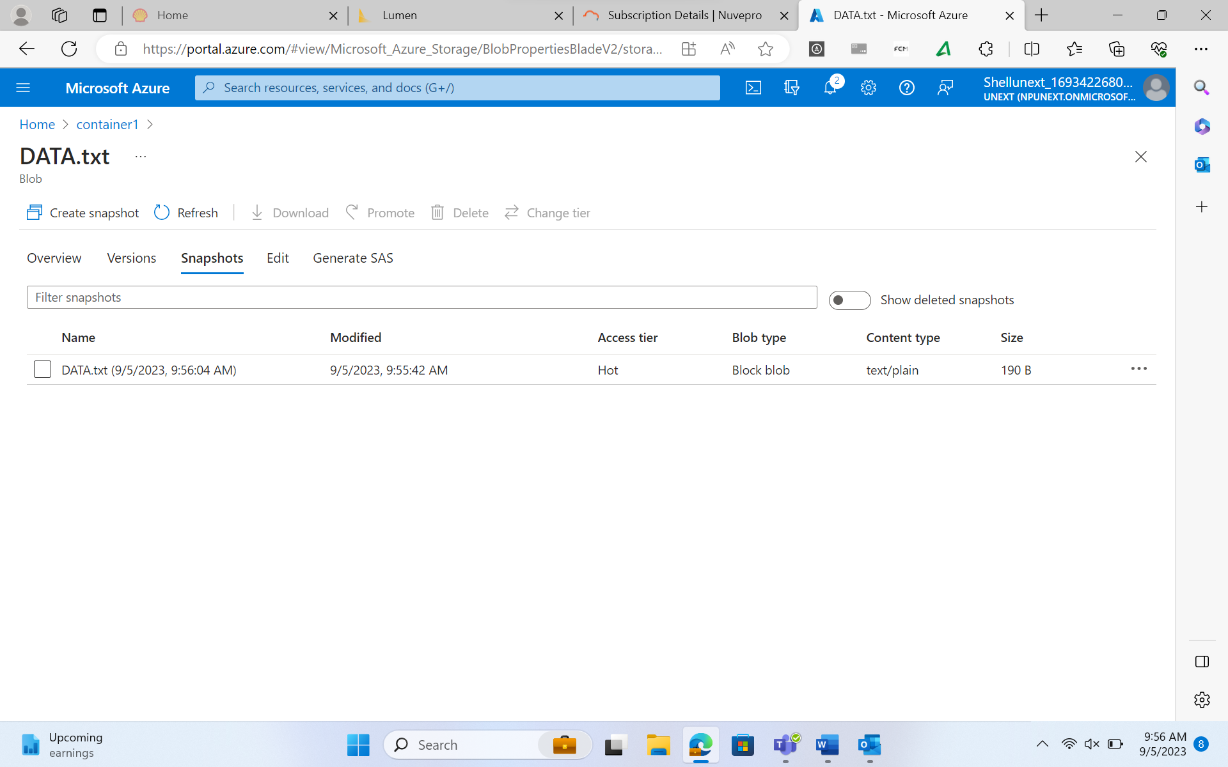

**Removing the data that we added:**

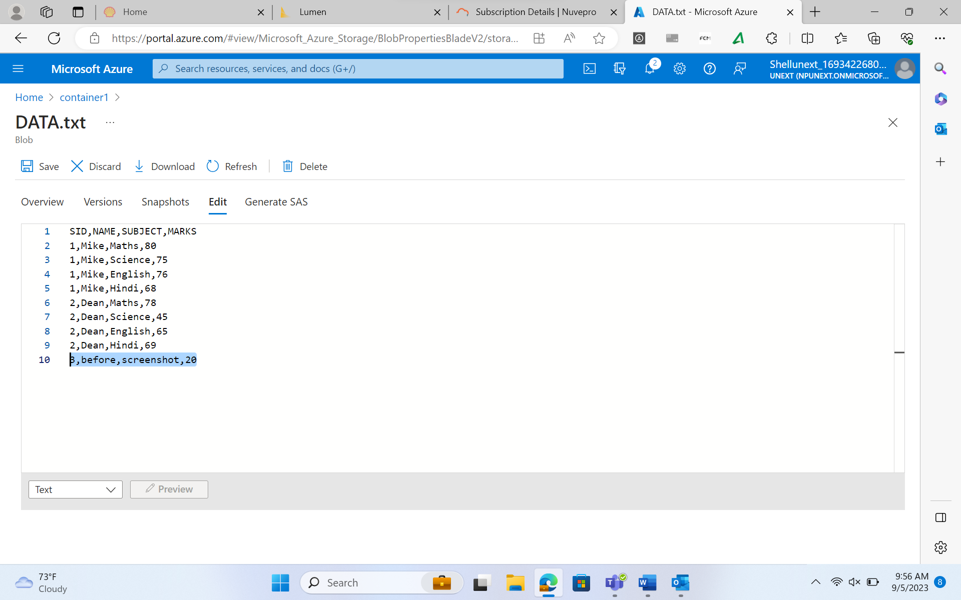

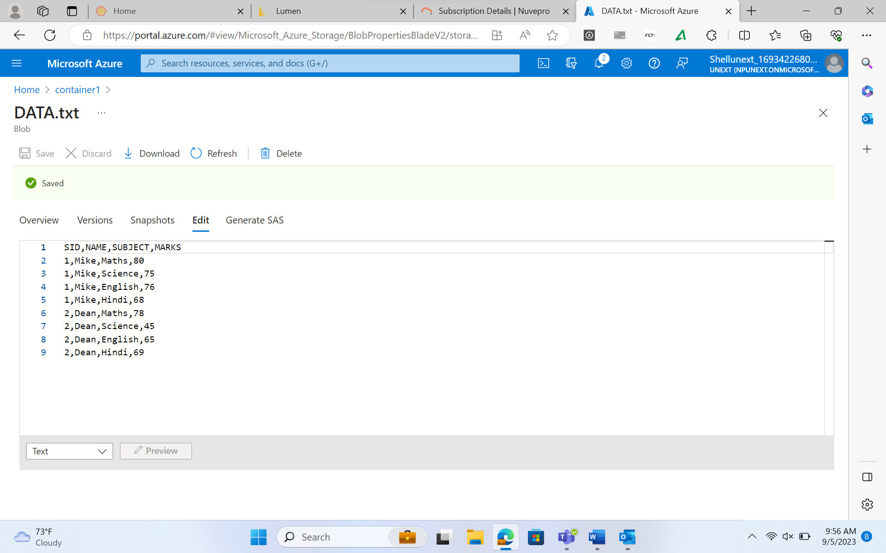

**Selecting the previously created snapshot and promoting it:**

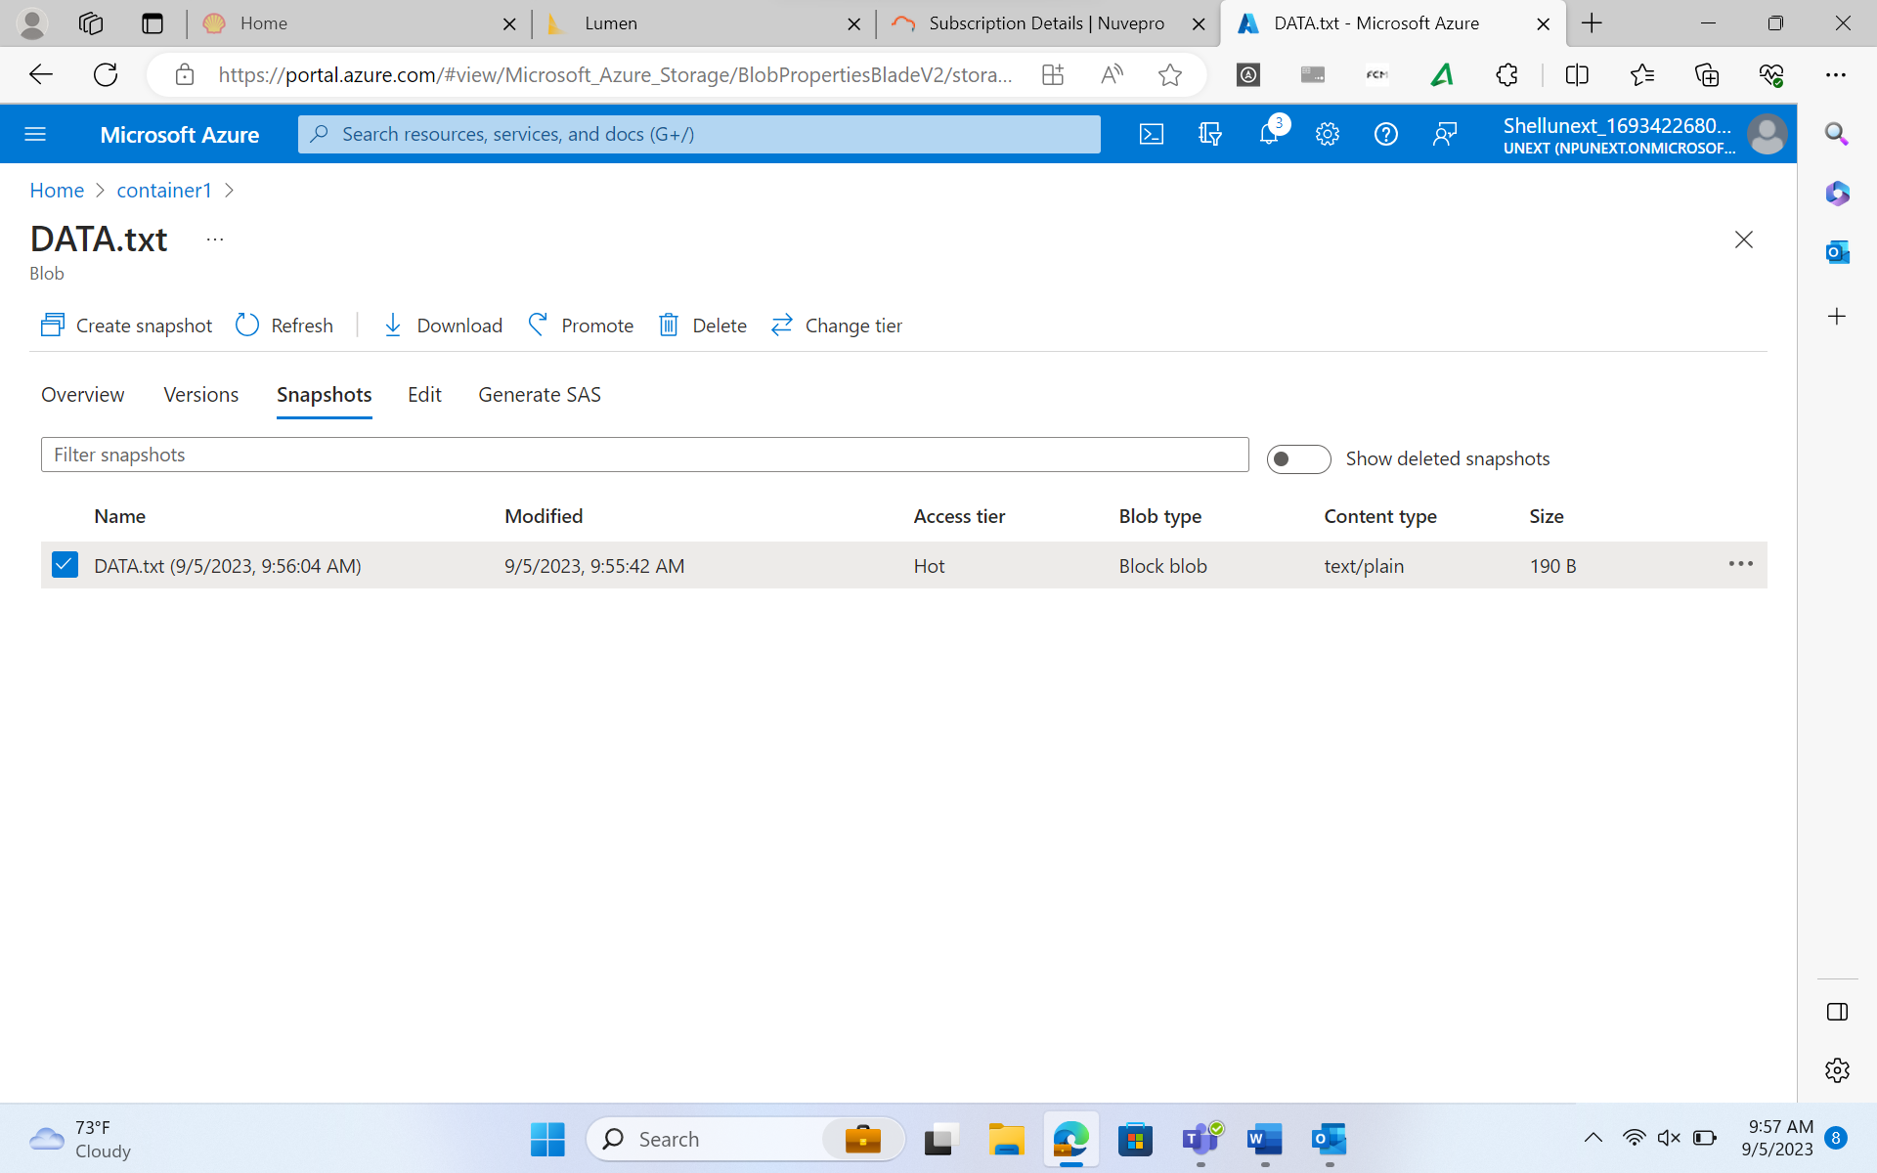

**Rechecking the file:**

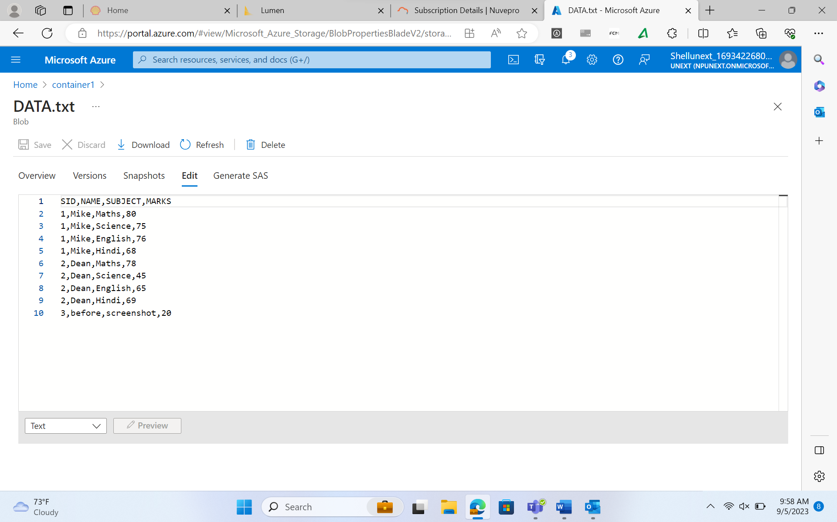

1. **FILE SHARES**

File Share in Azure Storage Account is a feature that allows you to create network file shares in the cloud using Azure Files. Azure Files is a fully managed file storage service that supports the Server Message Block (SMB) protocol, making it easy to share files across multiple virtual machines or on-premises systems.

A File Share is a container within an Azure Storage Account where you can store and manage files, similar to a network share on a traditional file server. It provides a hierarchical directory structure, and you can create, read, write, and delete files in the share using standard SMB protocols.

**Creating a file share:**

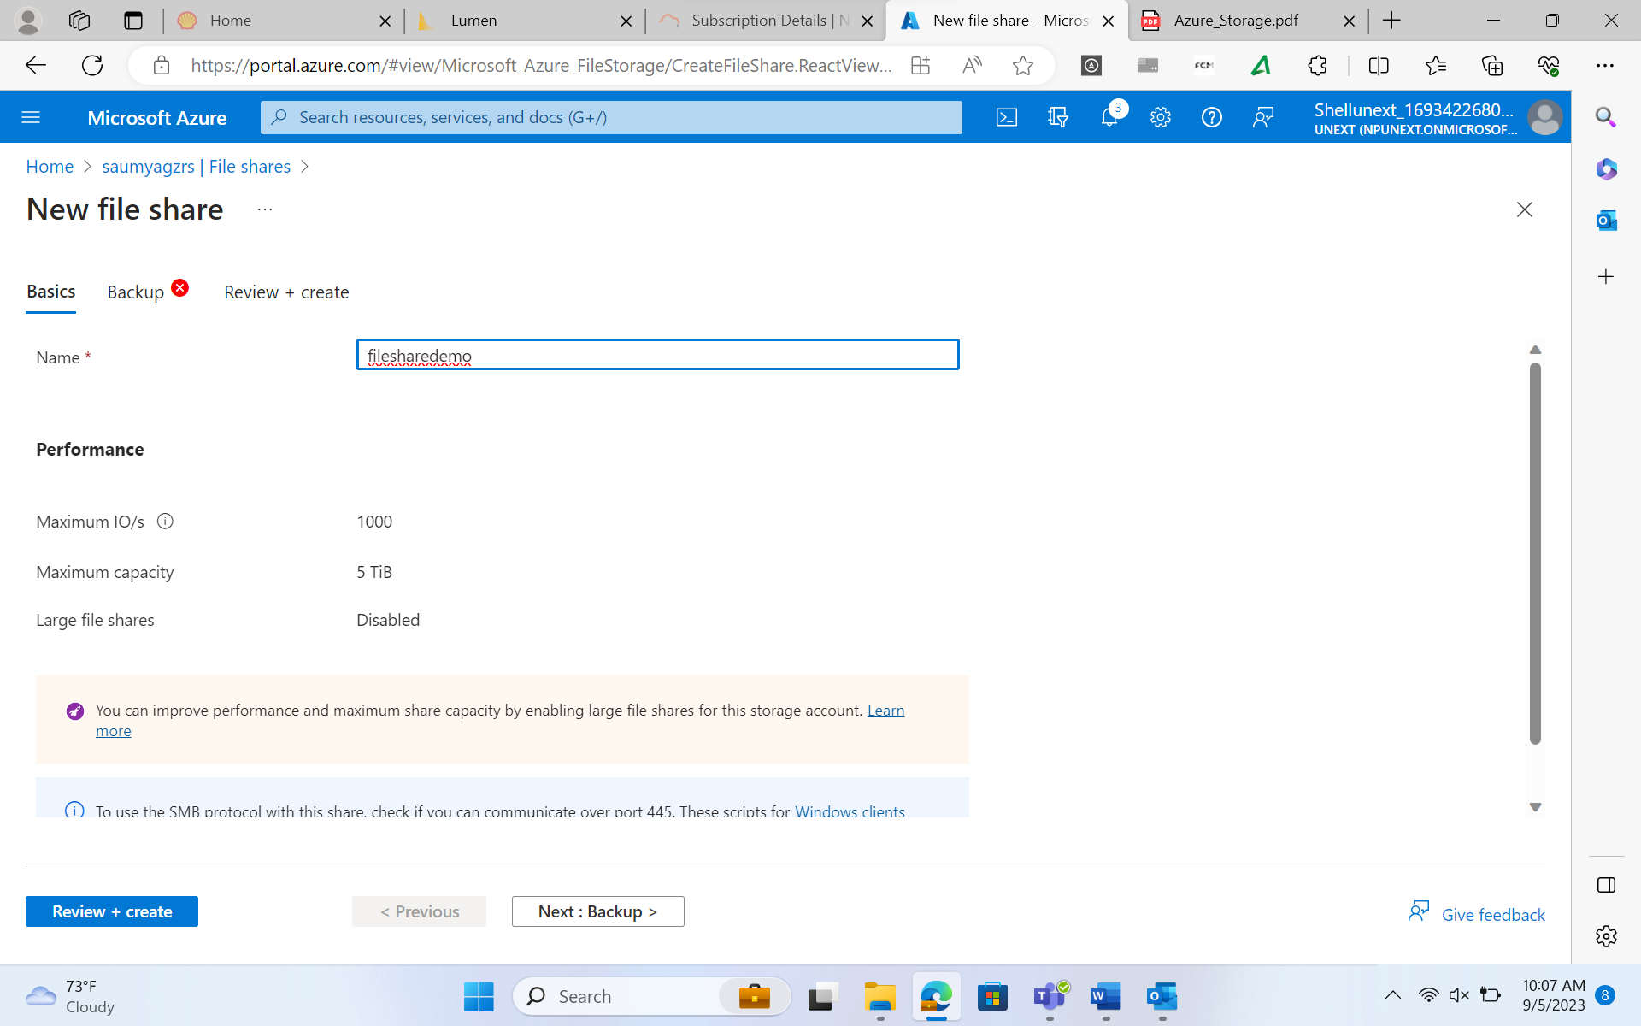

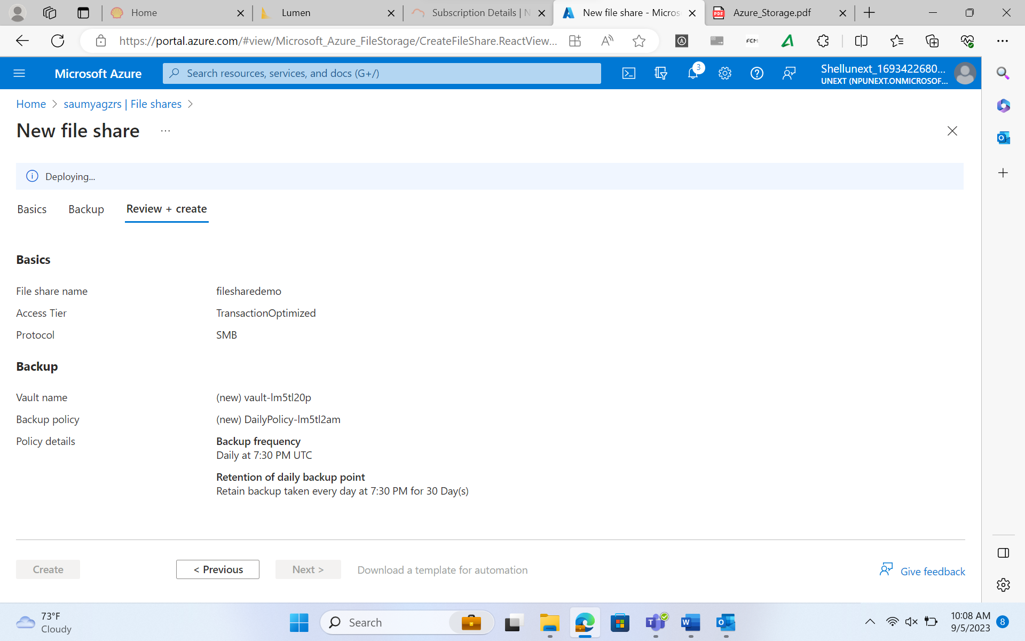

**Uploading Files in File Share**

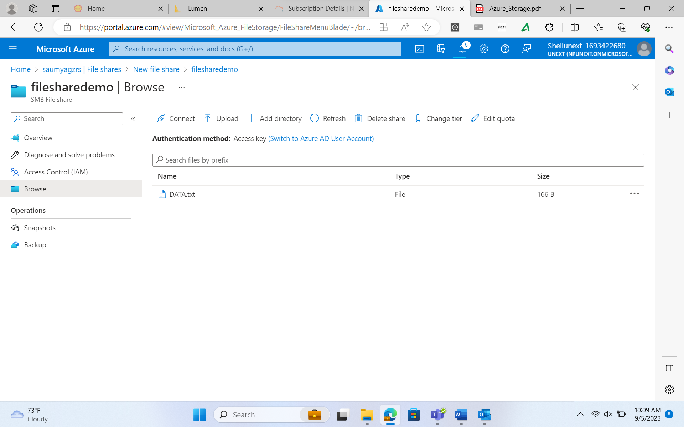

1. **QUEUES**

Azure Storage Queue is a scalable and highly available messaging service offered as part of Microsoft Azure's cloud computing platform. It enables the decoupling of components within an application, allowing them to communicate asynchronously and handle tasks independently. Azure Storage Queues are designed to facilitate communication between different components of a distributed application. One component can enqueue a message into a queue, and another component can dequeue and process the message at its own pace. This decoupling of sender and receiver allows for better scalability, fault tolerance, and load leveling in applications.

**Creating a queue**

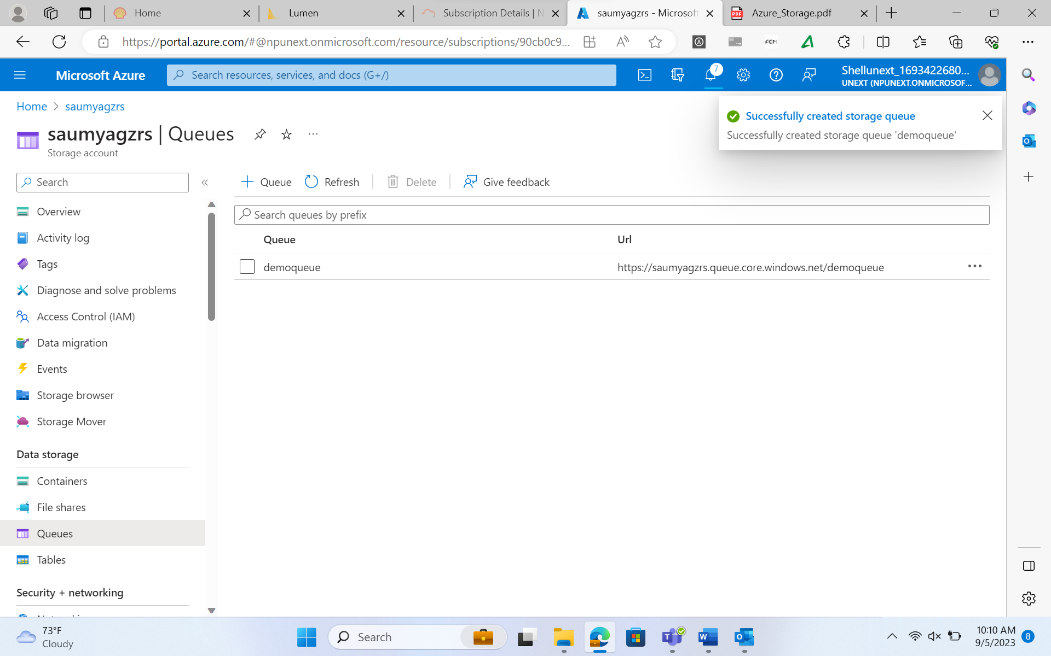

**Adding message in a queue**

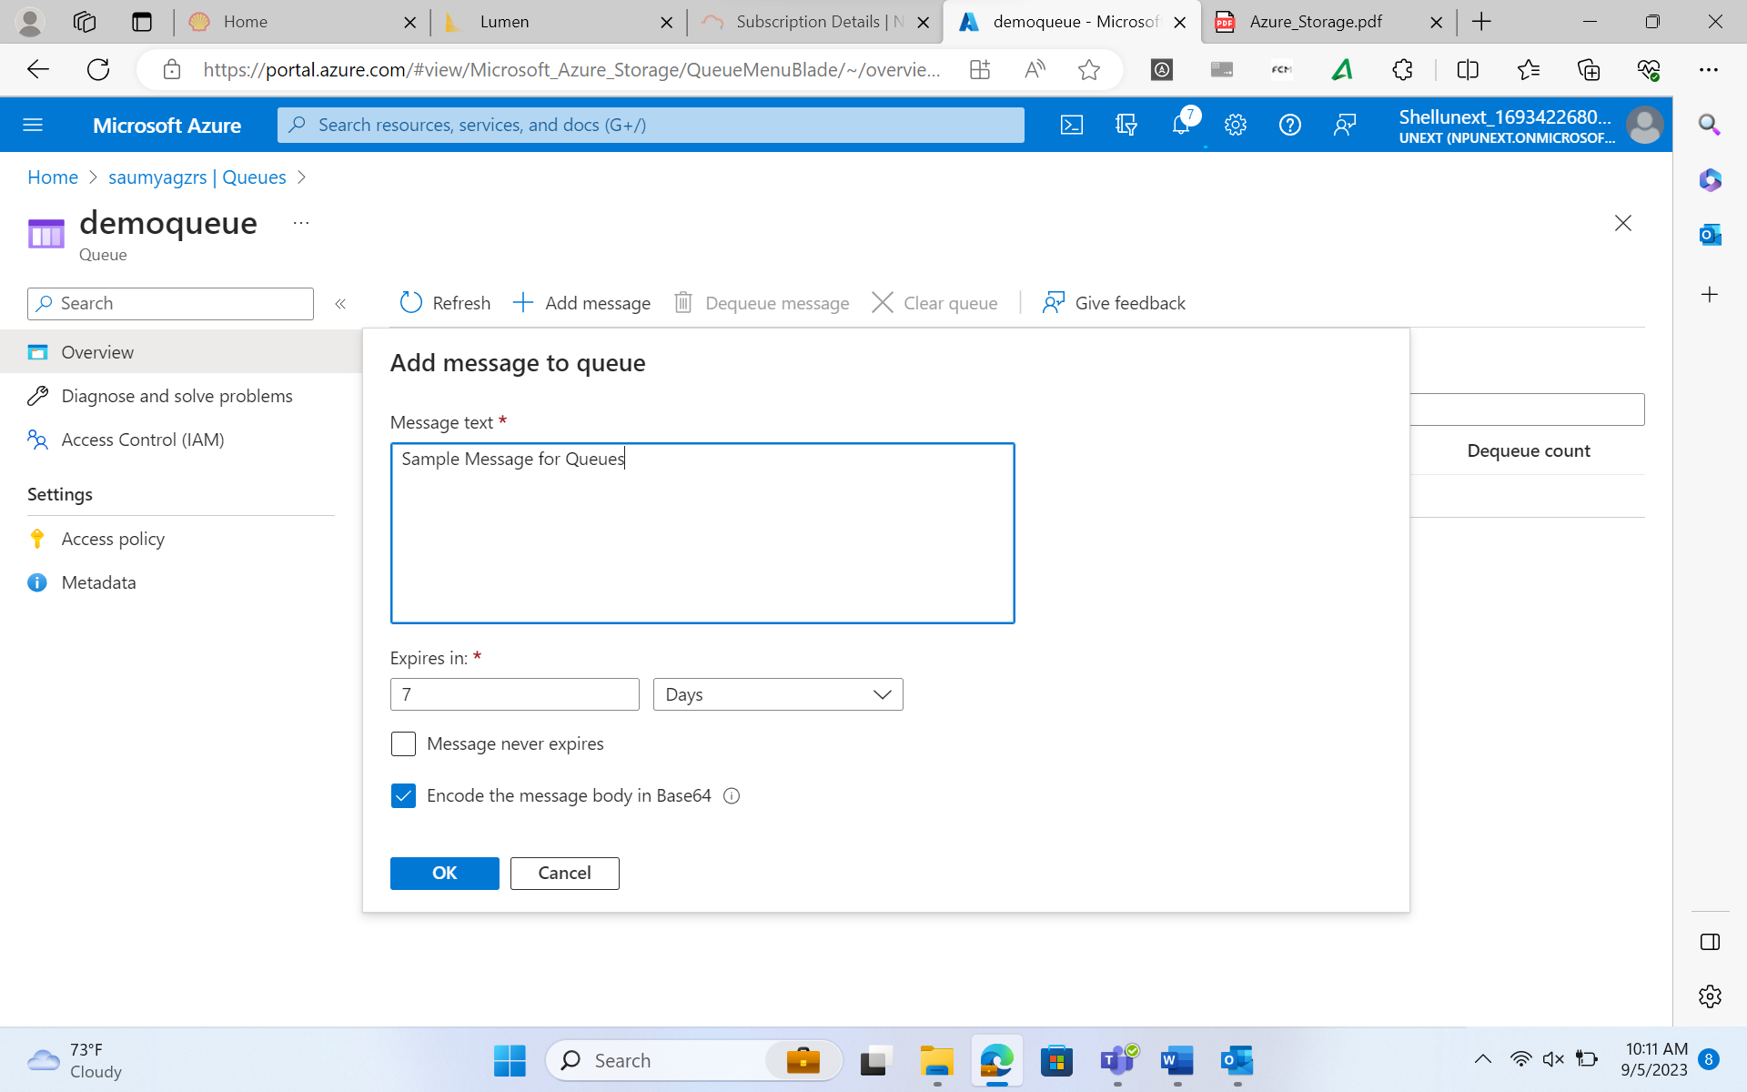

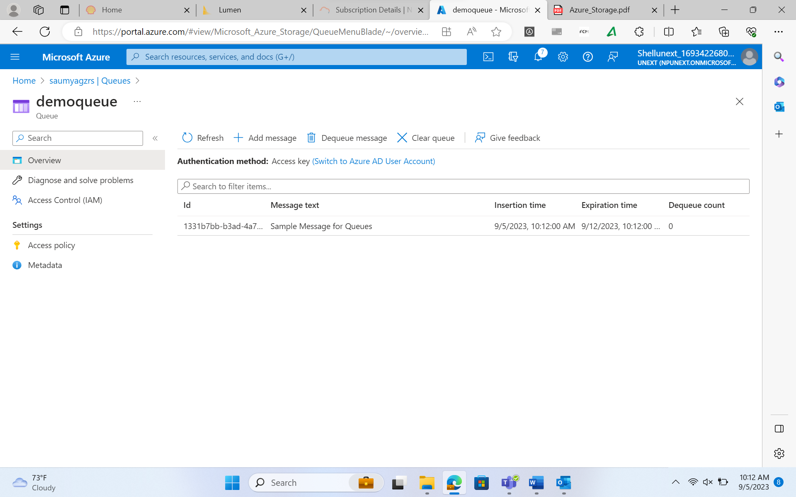

1. **TABLES**

Azure Table Storage is a NoSQL data storage service provided by Microsoft Azure, a cloud computing platform. It is designed to store semi-structured data in the form of tables, making it suitable for various use cases such as storing large amounts of structured data for web applications, IoT (Internet of Things) devices, and other data storage needs.

**Creating a table in azure:**

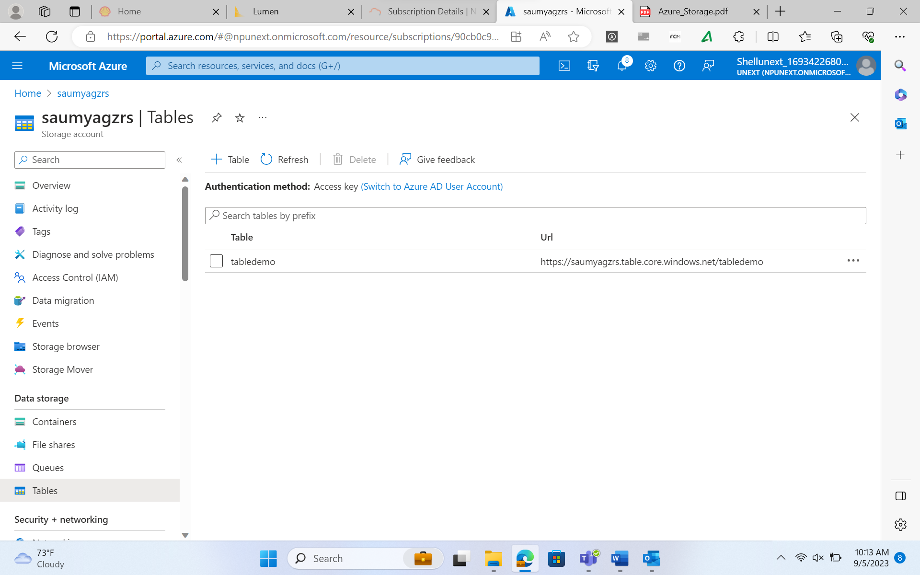

**Accessing the table from Storage Browser:**

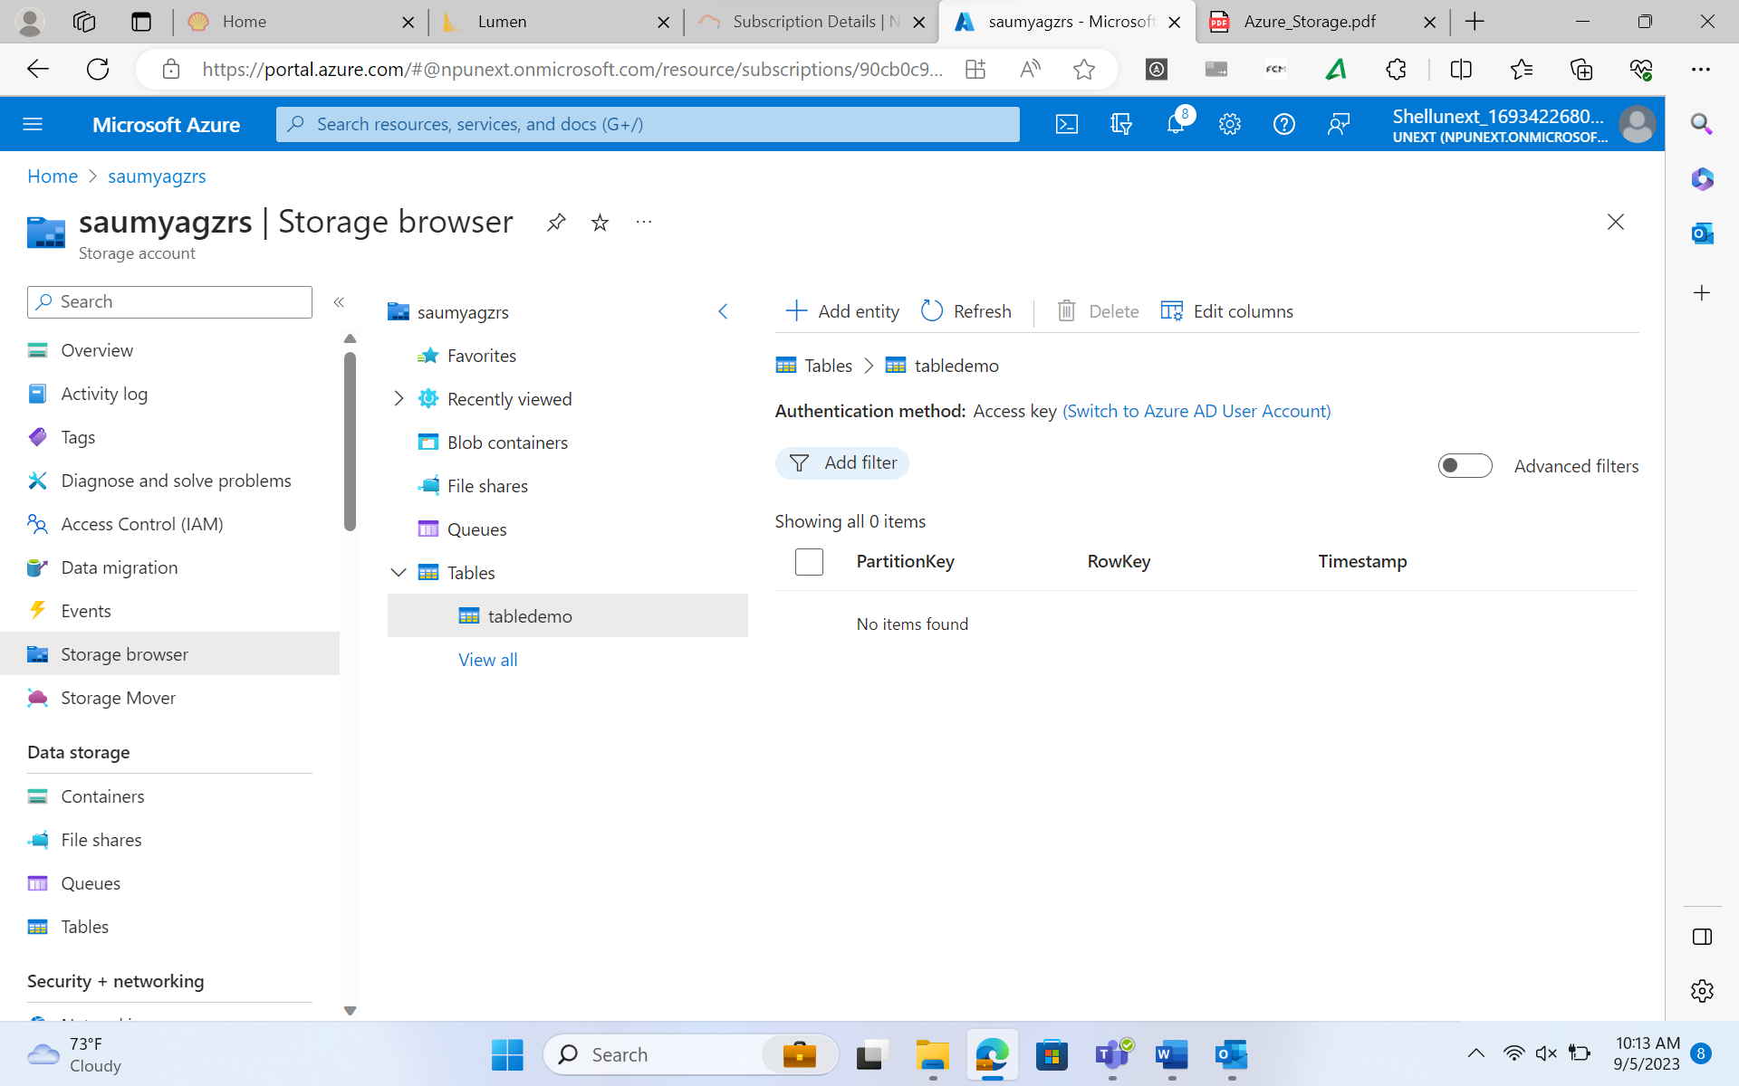

**Adding entities in the table:**

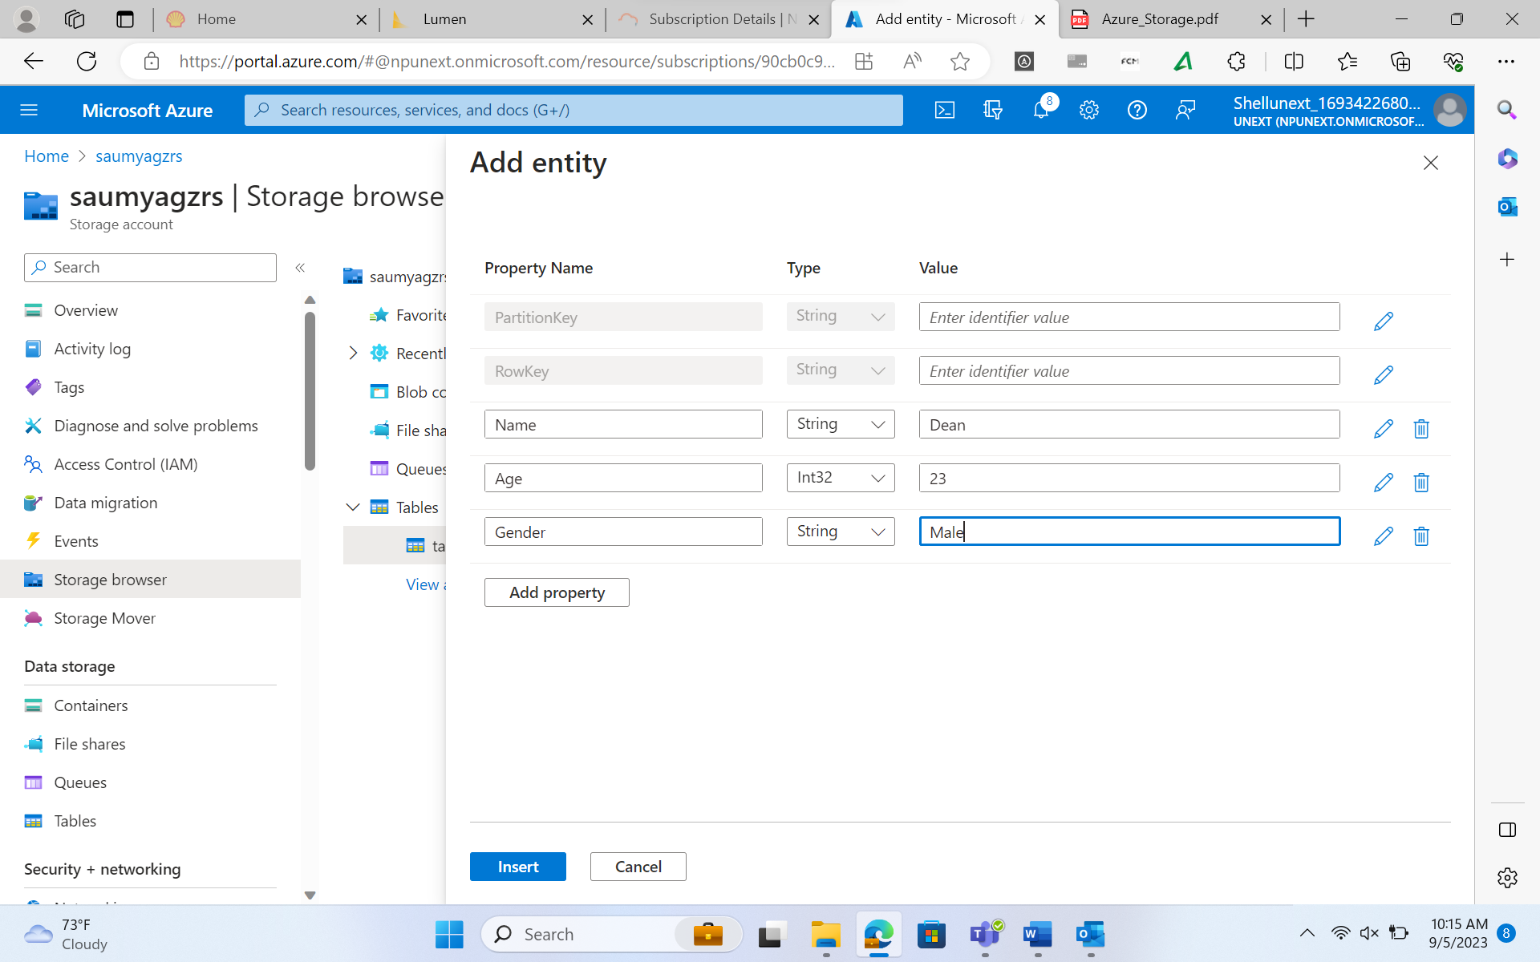

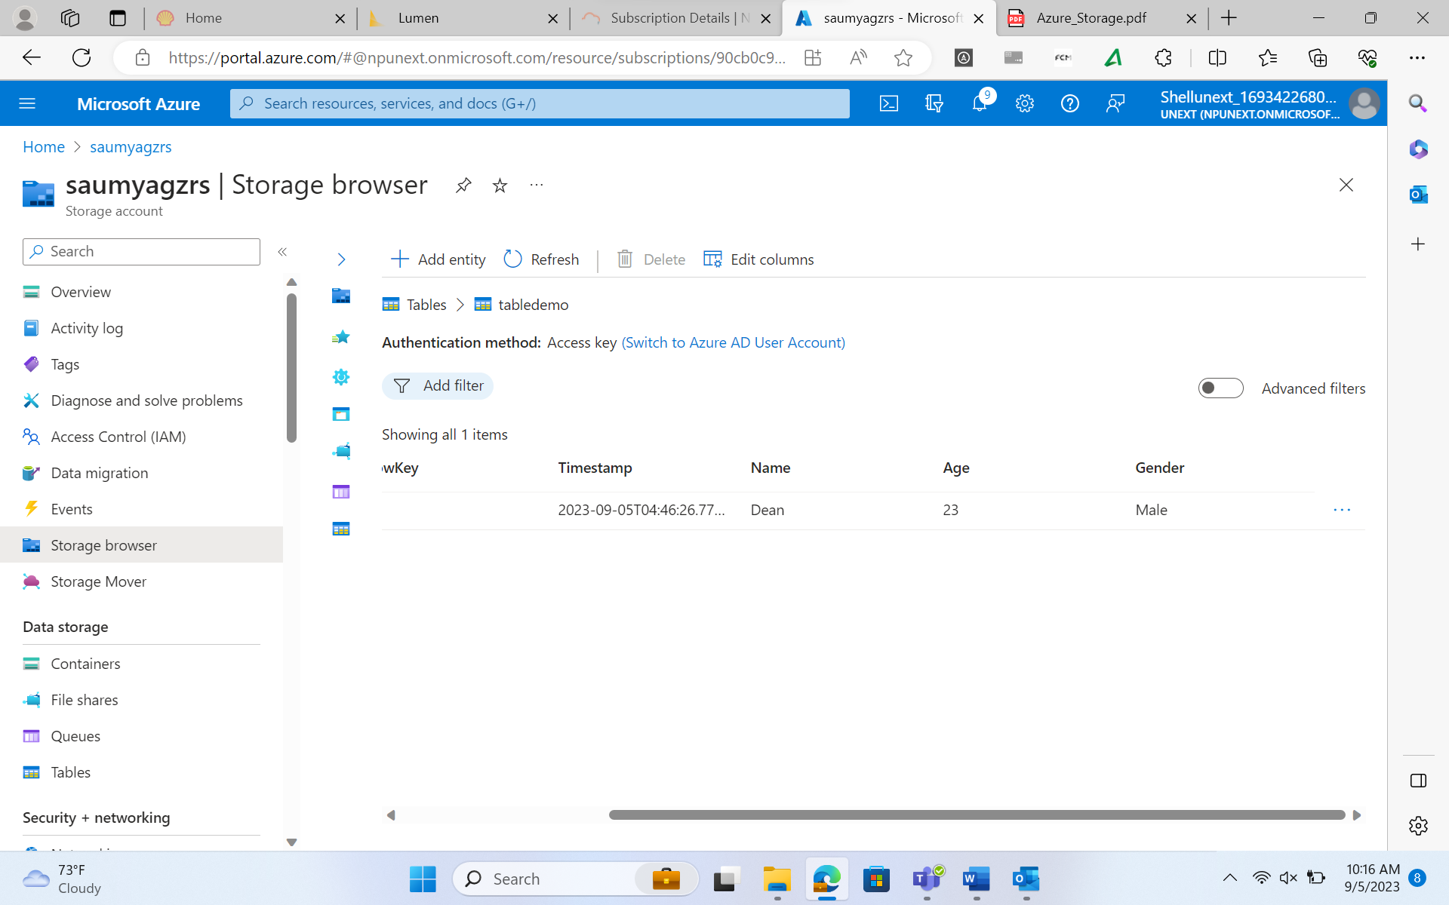

1. **HOT TIER:**

You should use the hot tier if you need frequent data accessibility (read and write operations) with low latency. Most of the transactional workload uses this tier to get optimal performance. This tier will charge you the highest storage cost and lowest access cost among all 3 tiers.

In the Container we uploaded a file. In the previous example. We can see here our file is in the Hot tier. This means we can download and Edit and then preview the data.

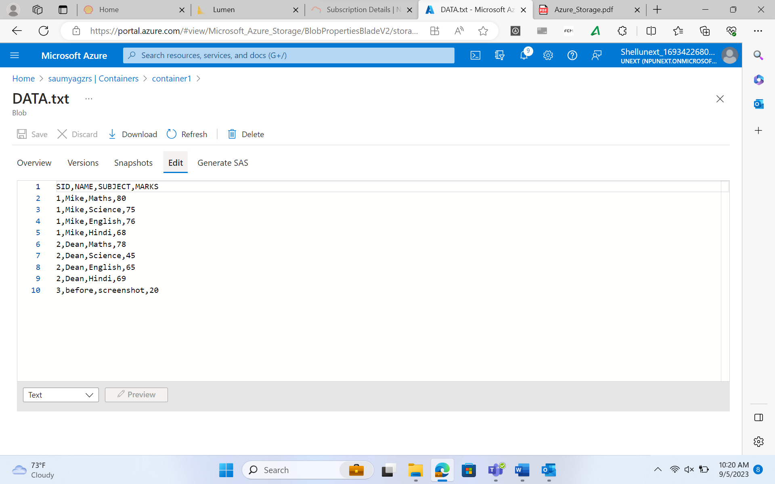

1. **COOL TIER:**

This tier is suitable for infrequent data access requirements. It also gives good performance and durability. The pricing for this tier is lower than the hot tier for storage cost and higher than the hot tier for access cost. This tier is ideal for backups, DR, or any unstructured data which are not used frequently. The minimum retention to store data in this tier is 30 days.

So right now our storage account is in Hot Tier. We need to change it to Cold Tier. Go to a storage account, under configuration, select the cold, and click on save.

We can also change access tier of one file.

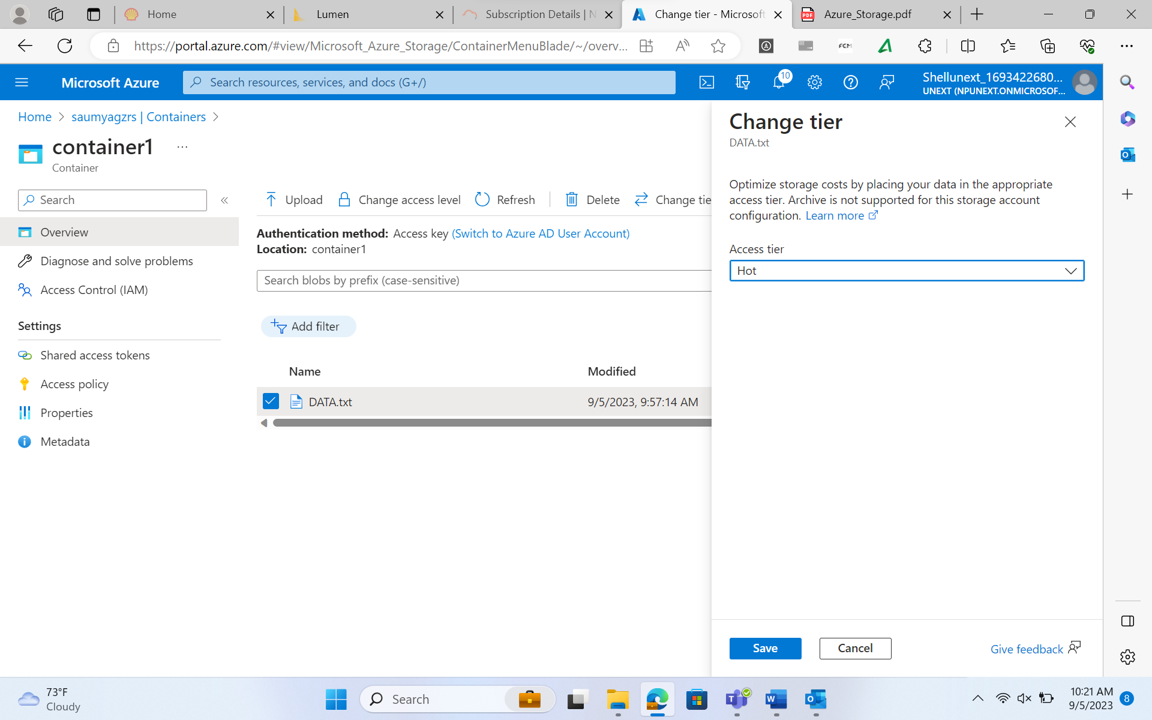

1. **ARCHIEVE TIER:**

This tier is priced lowest for storage cost and highest for access cost among all 3 access tiers. This is suitable for blob data that you use occasionally like long-term backup retentions, and any data which you want to preserve and will not use for a longer time. The data stored in this tier is in offline mode and cannot be read and modified. You need to rehydrate the data if you want to use it. The rehydration process may take a lot of time to serve you the actual data, so the performance is very low in this tier. You can store data in the achieve tier starting from 180 days onwards.

* Azure Active Directory Integration for authorizing request to blob, queue, and table resources. Microsoft recommends using Azure AD credentials to authorize request to data, when possible, for optimal security and ease of use. We can use azure role-based access control to manage the security principal permission to blob, queue, and table resources in the storage account.

1. **ACCESS KEYS**

Access keys in Azure Storage are used to authenticate and authorize access to various Azure Storage services, such as Blob Storage, Queue Storage, and Table Storage. These keys are essentially pairs of an account name and a key (either a primary or secondary key), which grant access to the associated storage account. Access keys provide a simple way to secure and manage access to your Azure Storage resources. You can use the access keys to authenticate and authorize access to your storage account in various ways:

* **Storage Explorer:** If you're using Microsoft's Azure Storage Explorer tool, you can provide the account name and either the primary or secondary access key to connect to your storage account.
* **Azure SDKs and Libraries:** When writing code to interact with Azure Storage services, you can use the access keys to authenticate. Most Azure SDKs and libraries provide a way to set the account name and access key in your application's configuration or code.
* **Azure PowerShell and Azure CLI:** You can use Azure PowerShell and Azure CLI commands to interact with Azure Storage. These tools allow you to set the storage account name and access key as part of their configuration.

1. **Shared Access Signatures (SAS):**

Shared Access Signatures (SAS) in Azure Storage provide a way to grant limited and time-bound access to specific resources within your Azure Storage account without sharing your account keys. SAS tokens are a more secure and flexible way to manage access to your storage resources compared to directly using access keys. There are two main types of SAS tokens in Azure Storage:

* Service SAS: Grants access to a specific service (e.g., Blob Storage, Queue Storage, Table Storage) and allows operations on multiple resources within that service.
* Account SAS: Grants access to one or more storage services and can be used to perform operations on different types of resources within those services.

**Generating SAS for a file:**

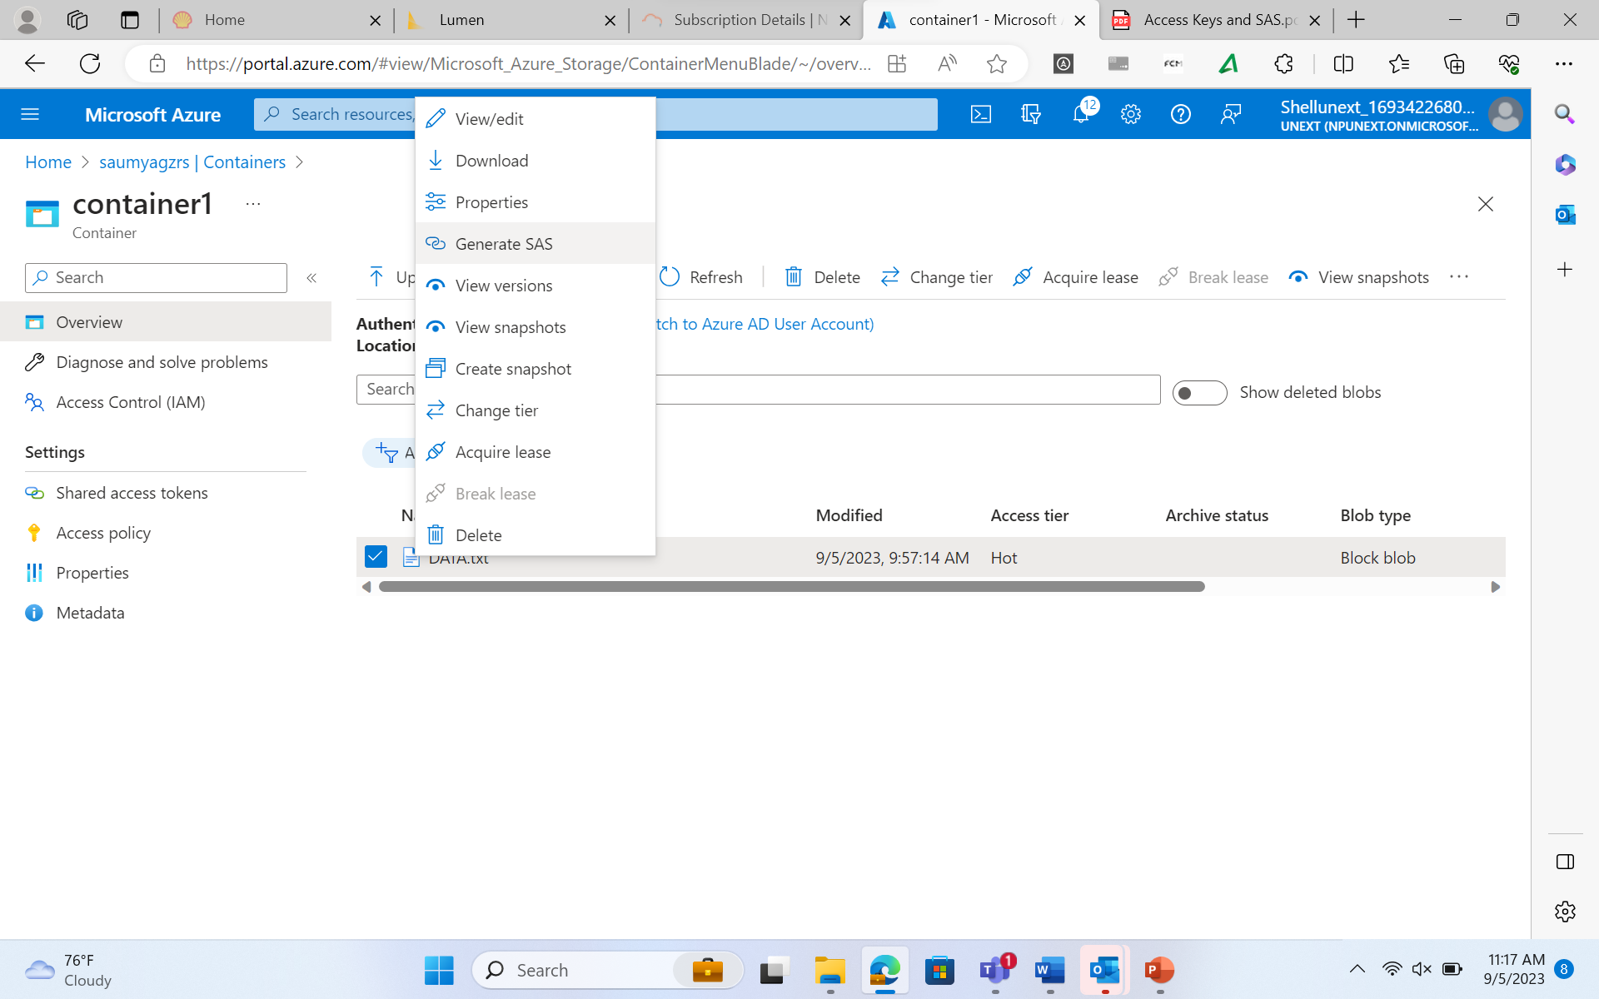

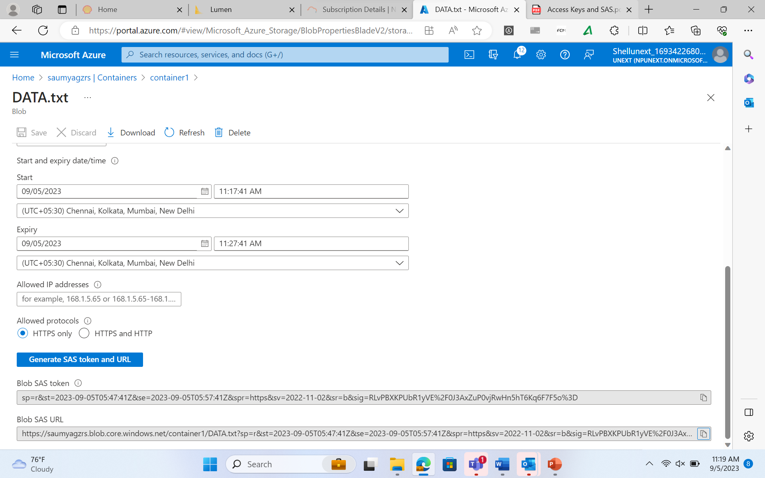

**Accessing the file using blob SAS URL**

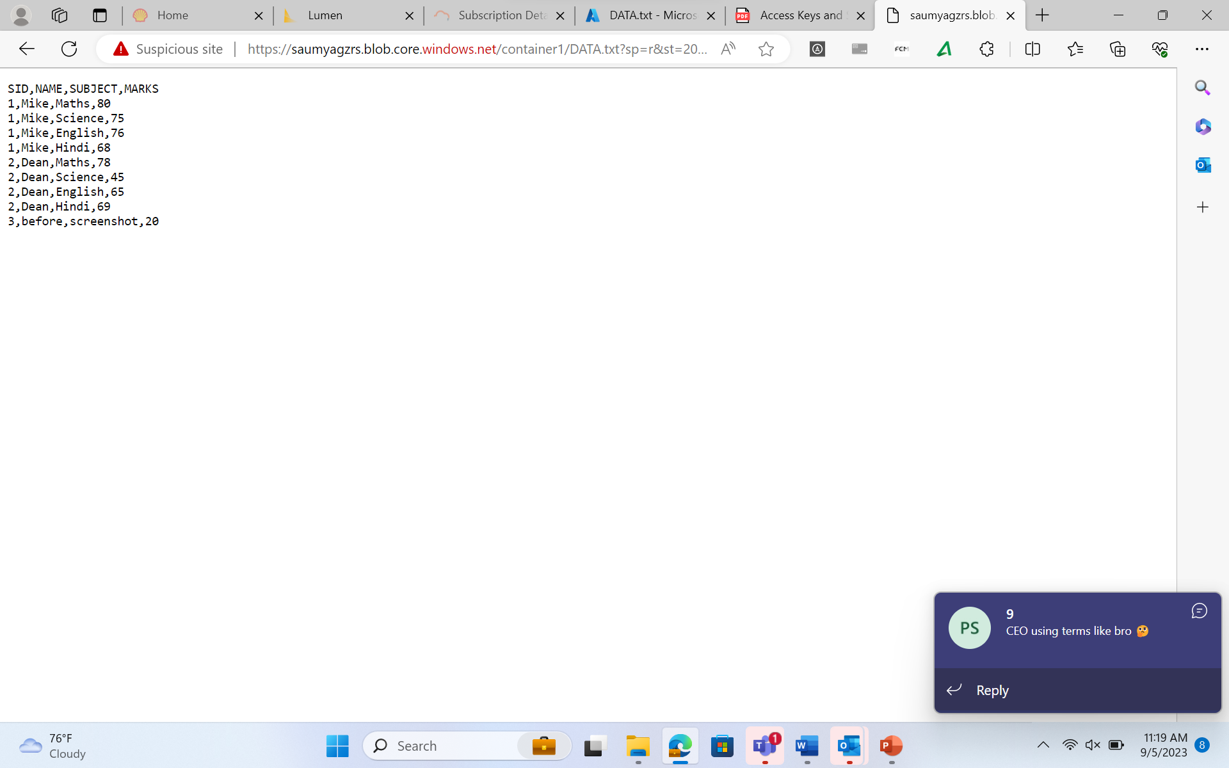

1. **Azure Data Factory:**

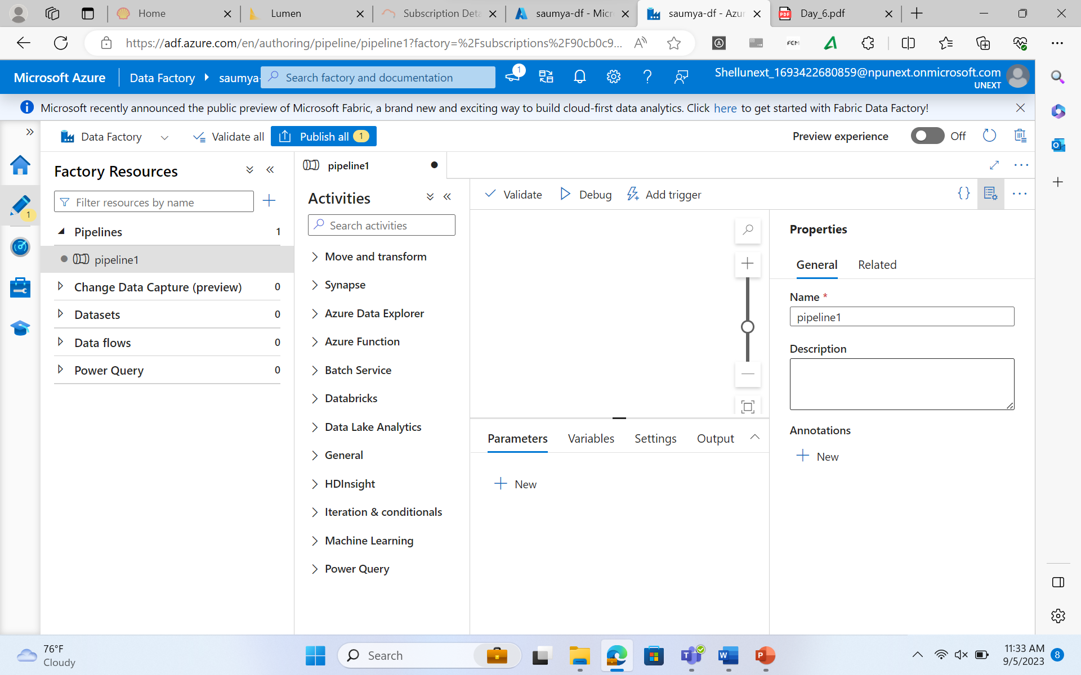

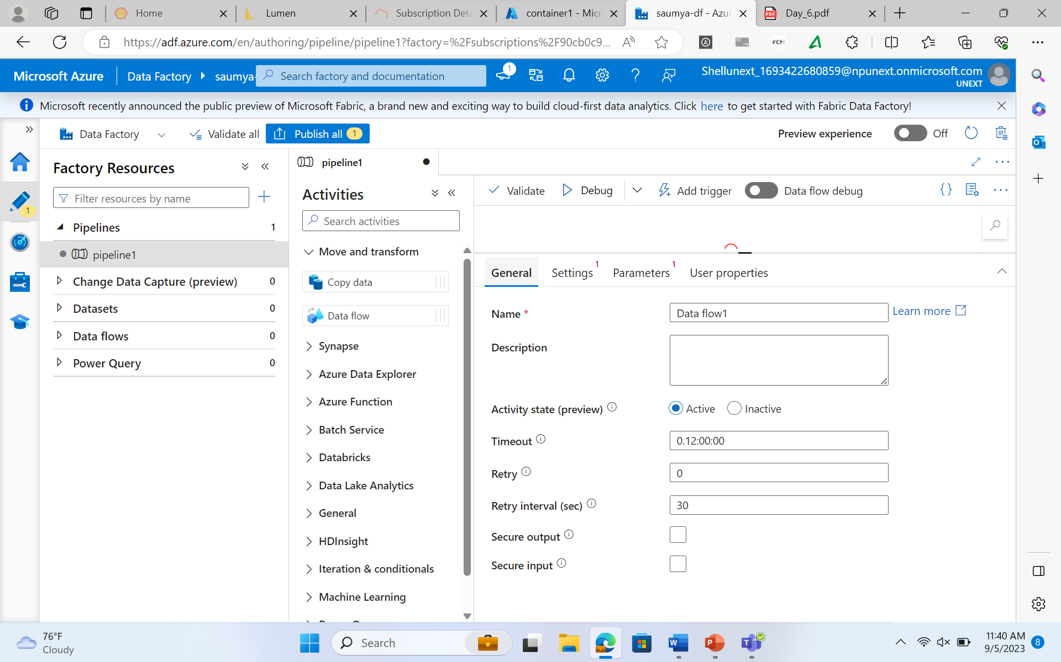

**ETL vs. ELT:**

**ETL (Extract, Transform, Load):**

* In traditional ETL, data is extracted from source systems, transformed to meet the target schema, and then loaded into the destination data store.

**ELT (Extract, Load, Transform):**

* In ELT, data is first extracted from source systems and loaded into the destination data store.
* Transformations are then applied within the destination data store.

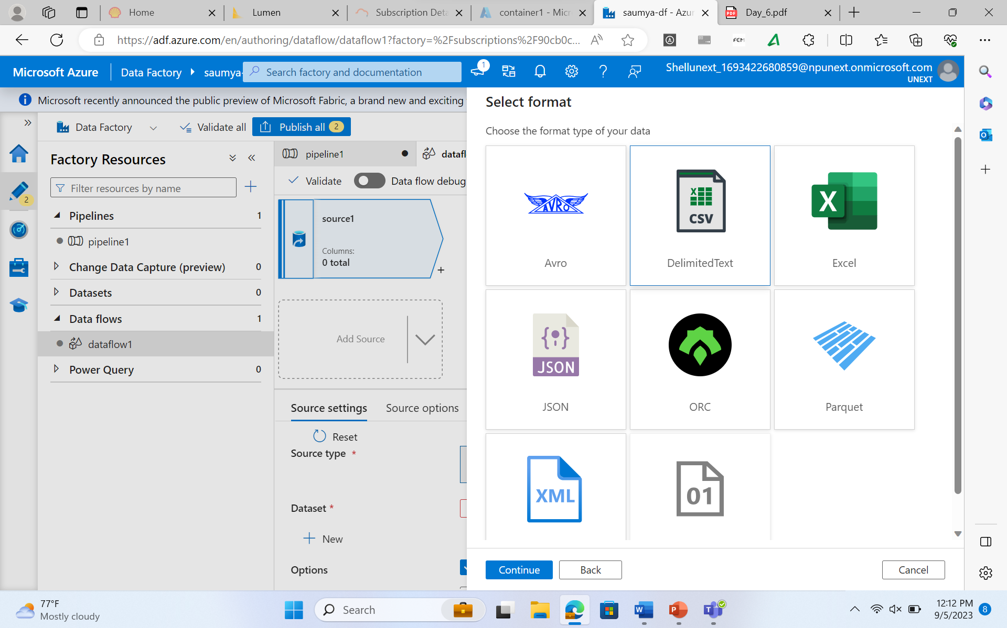

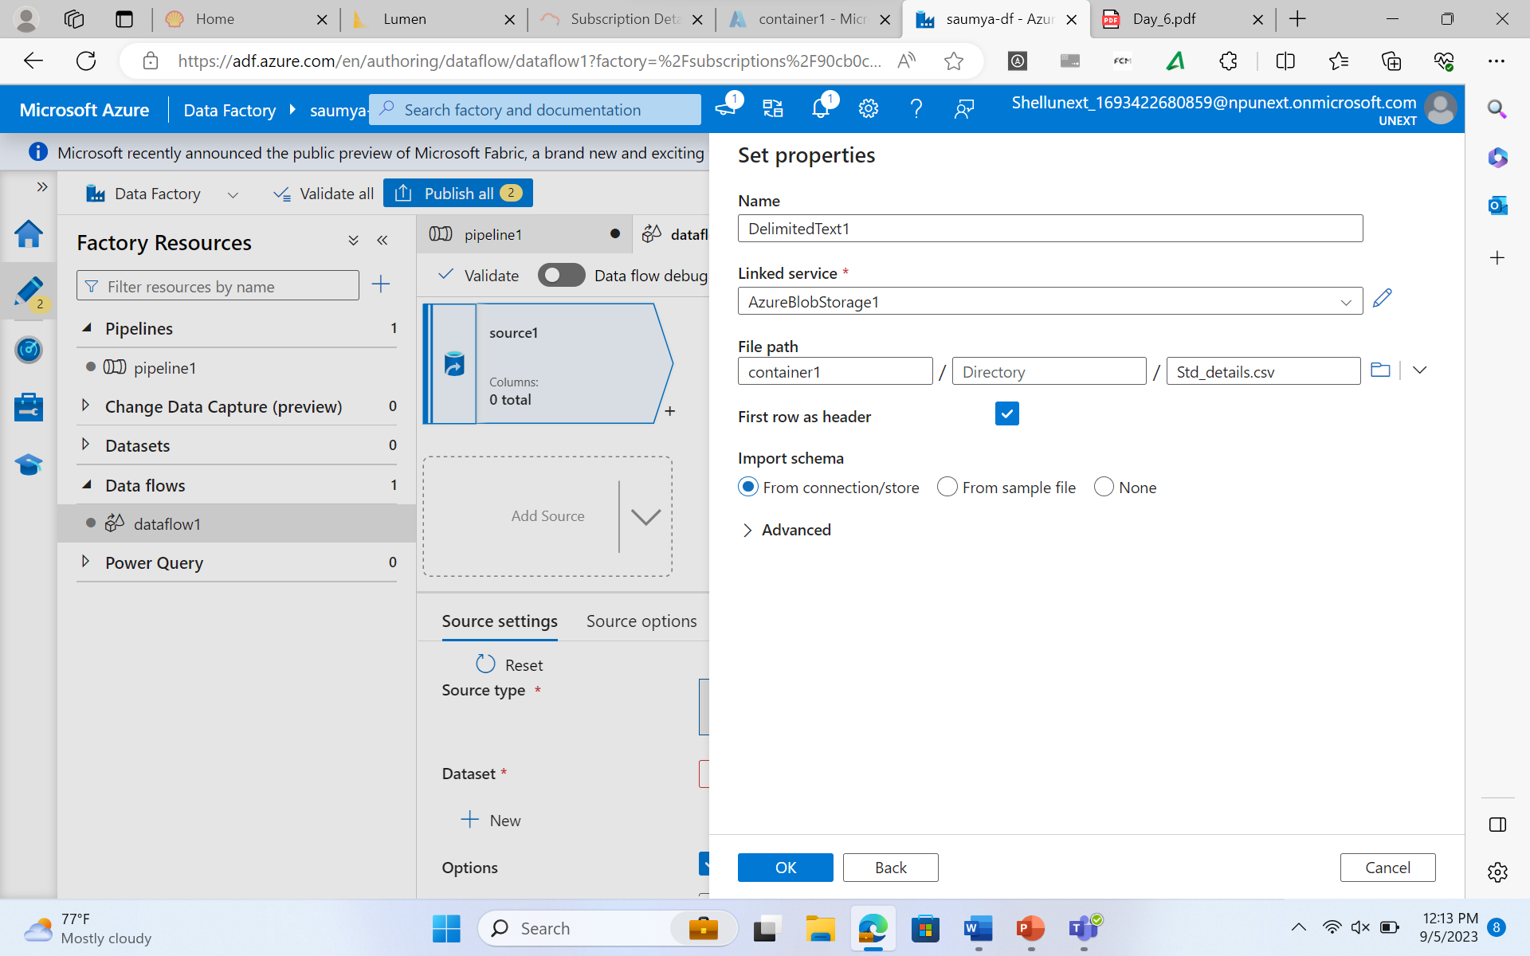

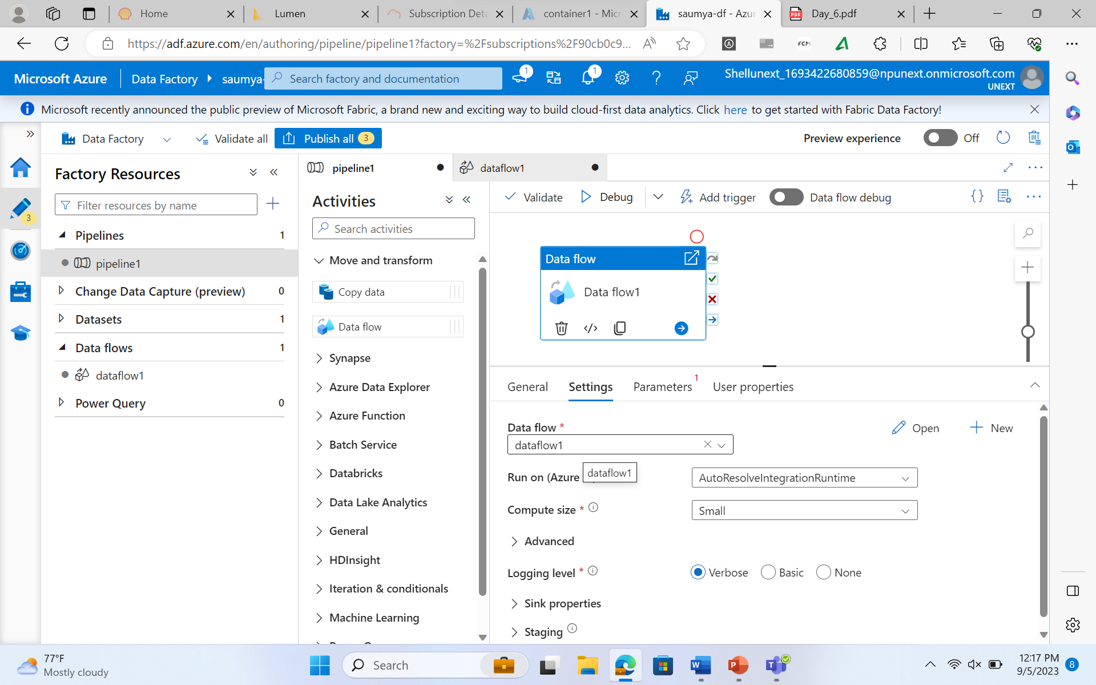 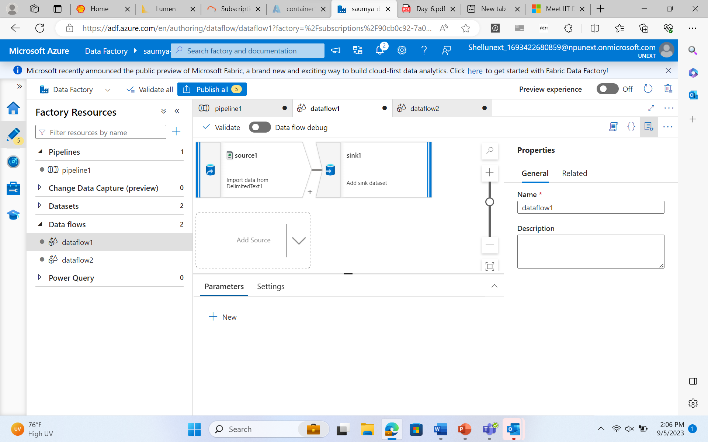

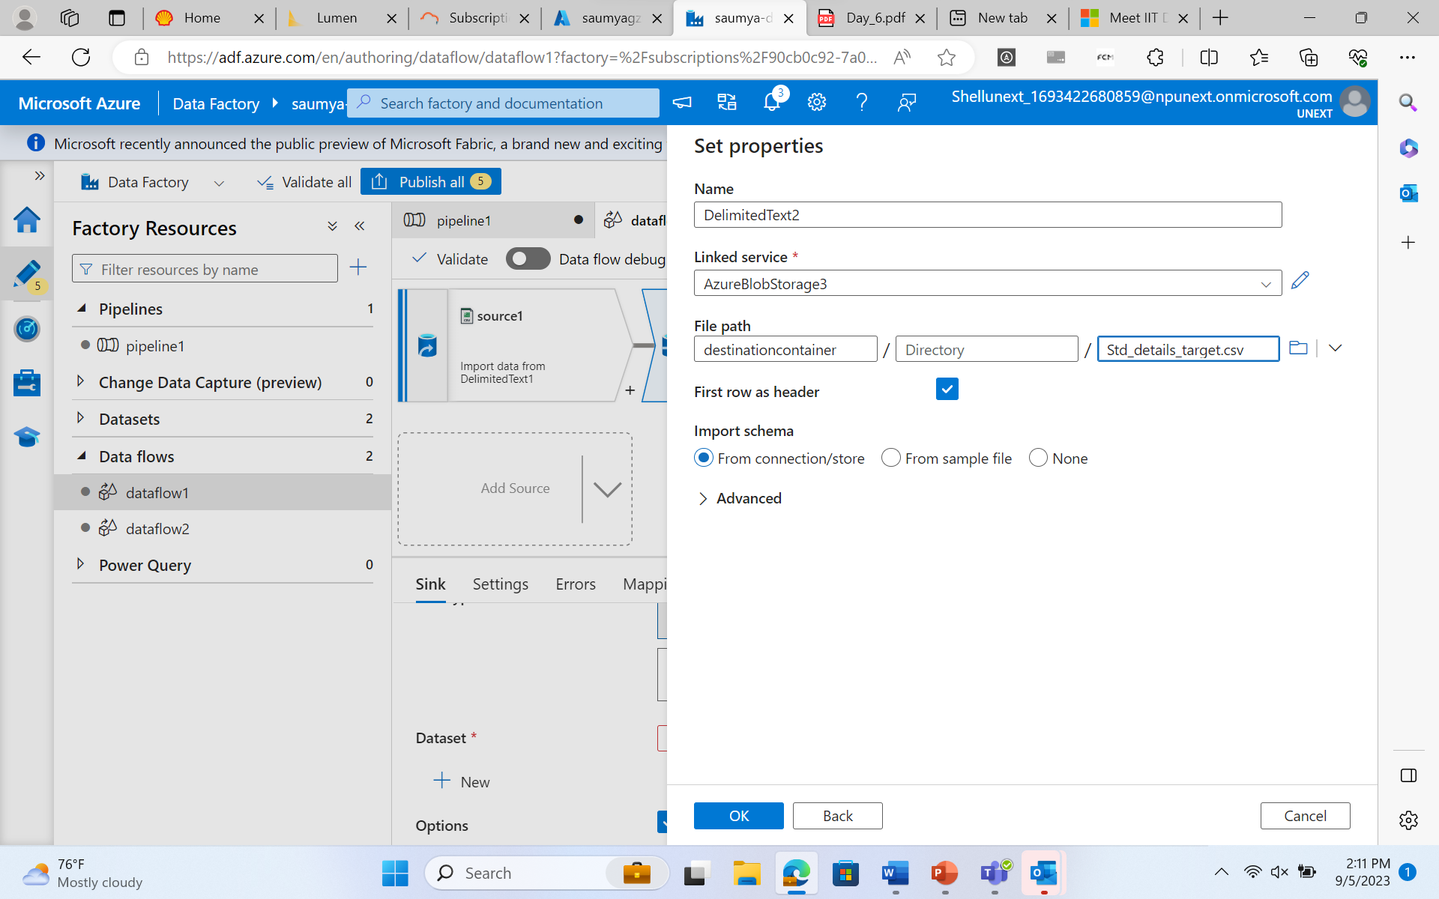

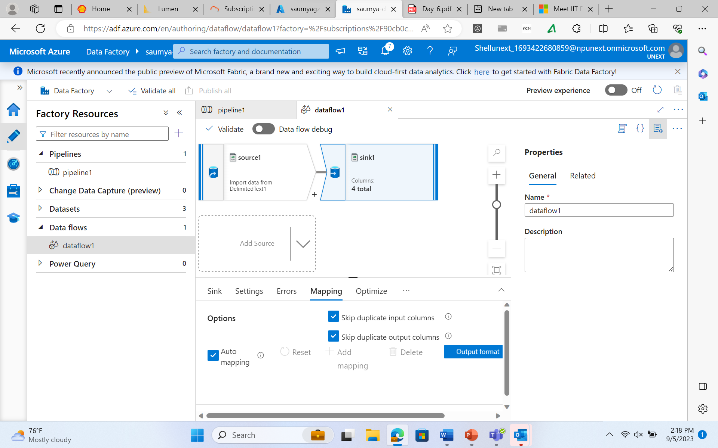

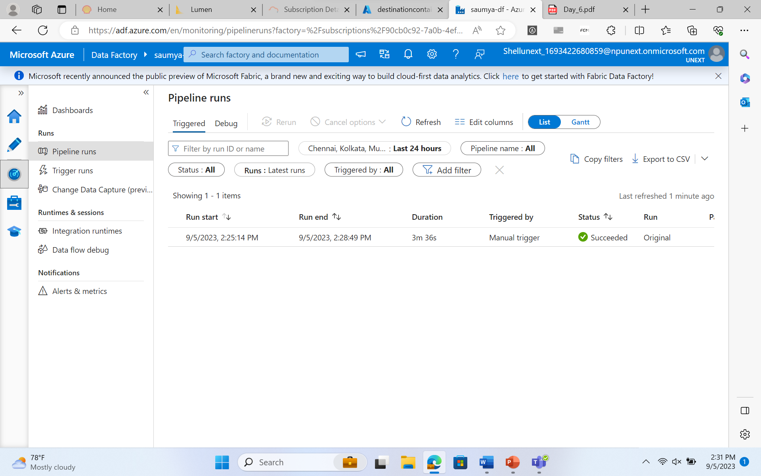

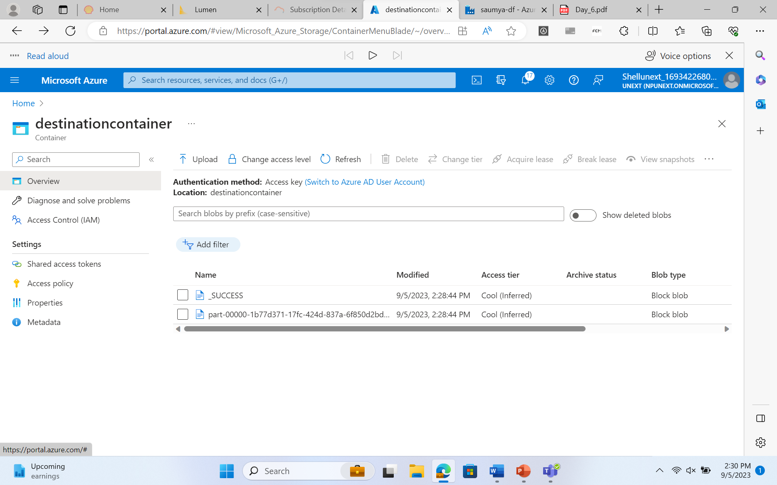

Creating a SQL Server

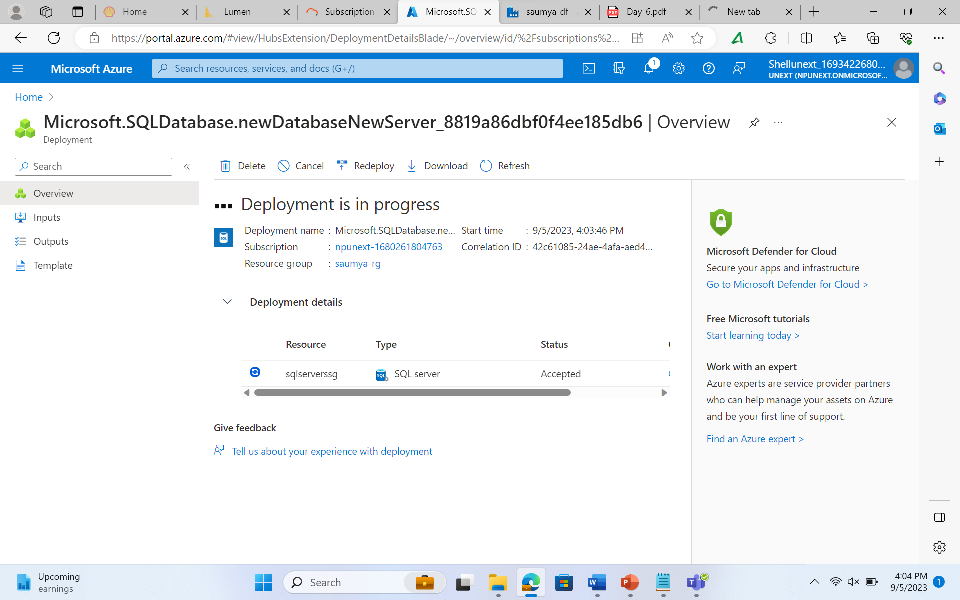

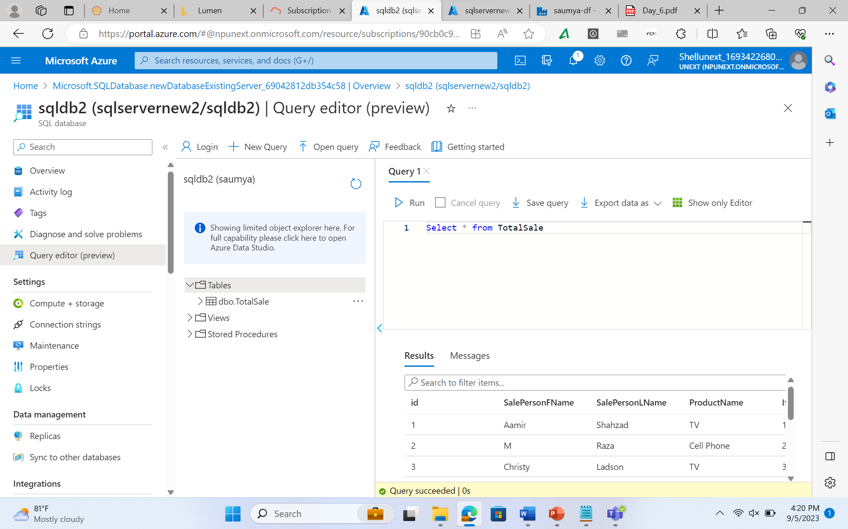

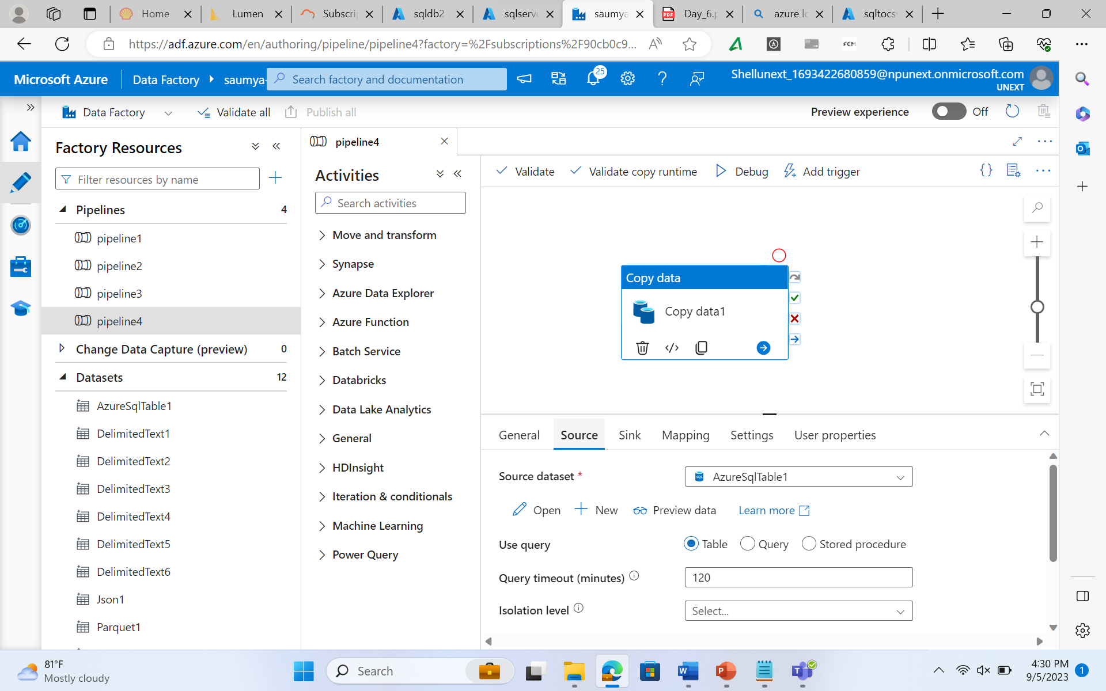

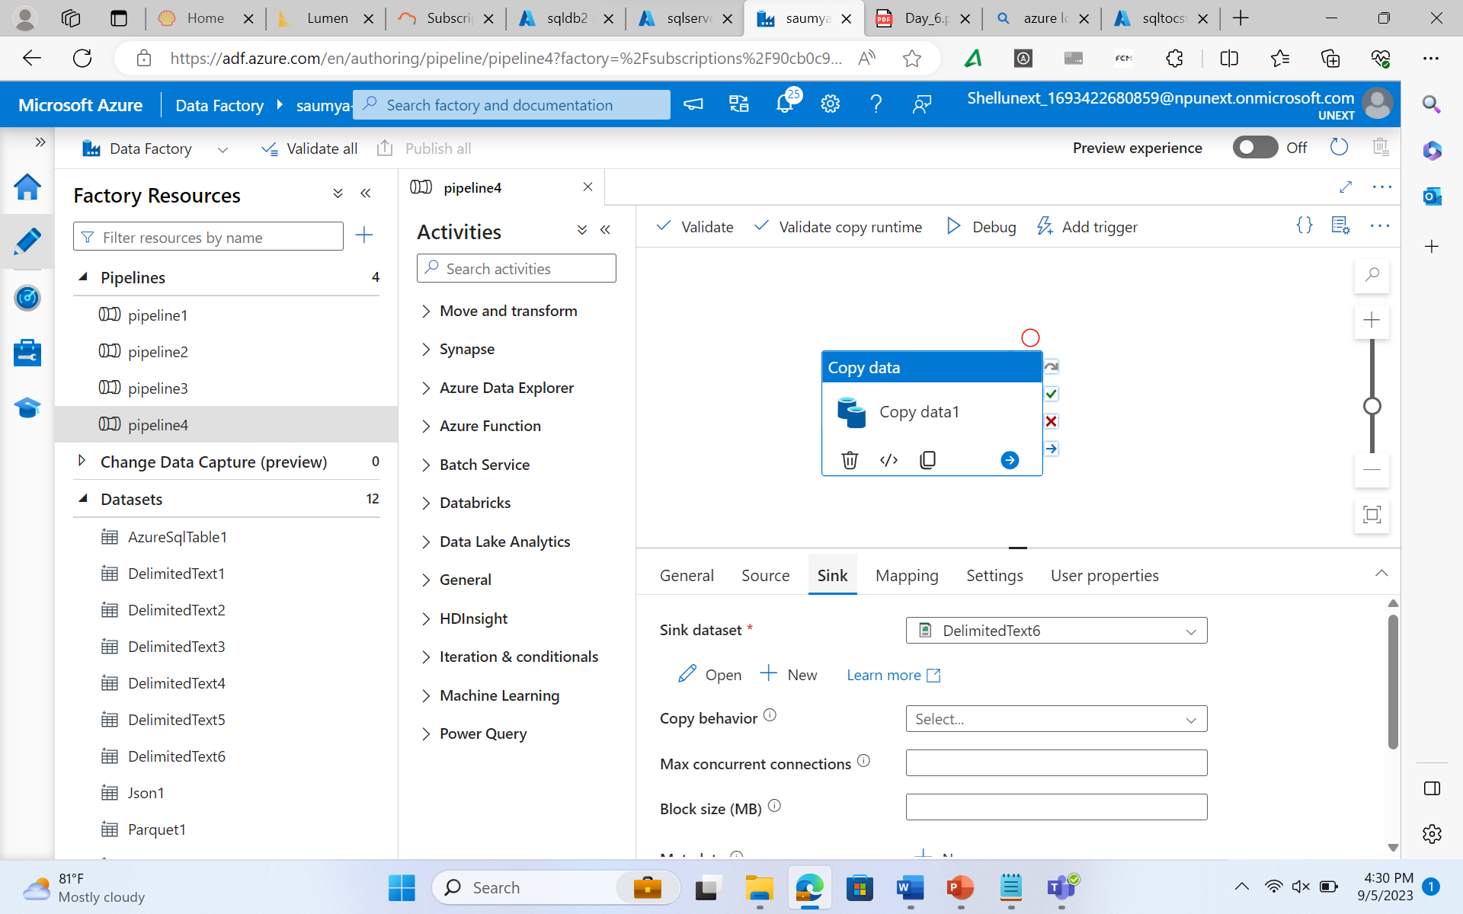

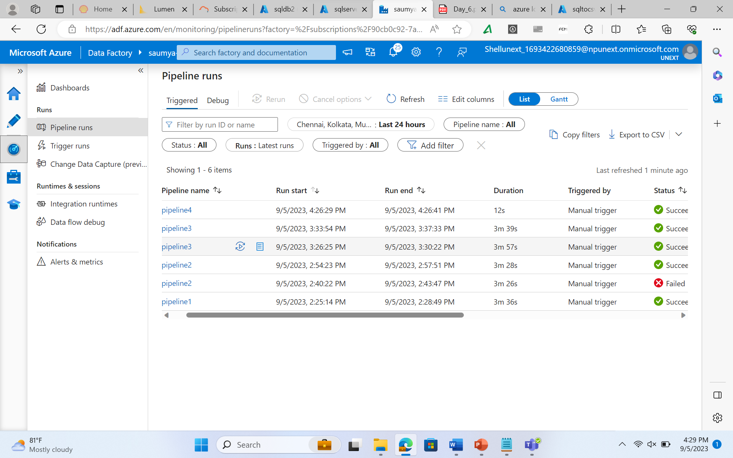

**Puzzle Answers:**

1. Data integration
2. Complex
3. Pipelines
4. Datasets
5. Triggers
6. Parameters
7. System Variables
8. ETL and ELT
9. Pipeline
10. Pipelines